**Classroom Behavior**

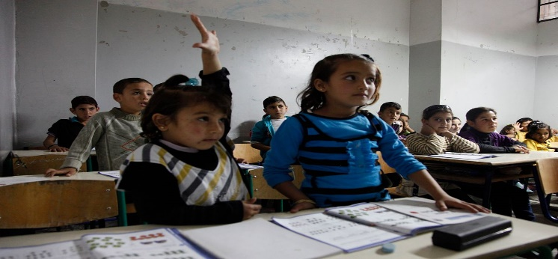

**Behavior:**



[This Photo](http://edtechpower.blogspot.com/2013/05/5-things-learners-today-should-be-doing.html) by Unknown Author is licensed under [CC BY-NC-ND](https://creativecommons.org/licenses/by-nc-nd/3.0/)

My expectations are as follows:

1. We are part of a family while in this classroom and we will therefore treat each other with love and respect.
2. We will keep our hands to ourselves and not on others.
3. We will have fun, learn alot and play each day without hurting anyone else physically or emotionally.

In your child’s folder each day, I will place one of three faces:

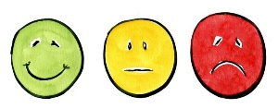

[This Photo](https://vp.commons.gc.cuny.edu/2017/03/01/faculty-observations-navigating-the-follow-up-conversation/) by Unknown Author is licensed under [CC BY-NC](https://creativecommons.org/licenses/by-nc/3.0/)

I will always send a note or talk with you personally if your child has had a challenging day and I could use your help. I try to handle most behavior problems in the classroom. However, I want us to be a team and work together to provide a wonderful school year.